

Dissertation on

“AI Phishing Simulation via Hybrid Agent-Based Modeling”

Submitted in partial fulfilment of the requirements for the award of the degree
of
Bachelor of Technology
in
Computer Science & Engineering

UE23CS320A – Capstone Project Phase - 1

Project_ID: PW26_

Submitted by:

Adithya Kallaje  B. Thanav Reddy  Dattatreya K A  Krishna Venkatesh | PES1UG23CS025  PES1UG23AM079  PES1UG23CS174  PES1UG23AM148

Under the guidance of

Dr.Sapna V M
Associate Professor
PES University

August - December 2025

DEPARTMENT OF COMPUTER SCIENCE AND ENGINEERING
FACULTY OF ENGINEERING
PES UNIVERSITY

(Established under Karnataka Act No. 16 of 2013)

100 feet Ring road, BSK 3rd stage, Hosakerehalli, Bengaluru – 560085



PES UNIVERSITY

(Established under Karnataka Act No. 16 of 2013)
100ft Ring Road, Bengaluru – 560 085, Karnataka, India

FACULTY OF ENGINEERING

CERTIFICATE

This is to certify that the dissertation entitled

‘AI Phishing Simulation via Hybrid Agent-Based Modeling’

is a bonafide work carried out by

Adithya Kallaje  B. Thanav Reddy  Dattatreya K A  Krishna Venkatesh | PES1UG23CS025  PES1UG23AM079  PES1UG23CS174  PES1UG23AM148

In partial fulfilment for the completion of Fifth-semester Capstone Project Phase - 1 (UE23CS320A) in the Program of Study -Bachelor of Technology in Computer Science and Engineering under rules and regulations of PES University, Bengaluru during the period Aug. 2025 – Dec. 2025. It is certified that all corrections/suggestions indicated for internal assessment have been incorporated in the report. The dissertation has been approved as it satisfies the 5th-semester academic requirements in respect of project work.

Signature  Dr.Sapna V M  Associate Professor | Signature  Dr.Shylaja S S  Chairperson | Signature  Dr. K S Sridhar  Dean of Faculty and Registrar

External Viva
Name of the Examiners  1. __________________________  2. __________________________  __________________________ | Signature with Date  __________________________  __________________________

DECLARATION

We hereby declare that the Capstone Project Phase - 1 entitled “Title of the project” has been carried out by us under the guidance of <Dr/Prof. Guide Name, Designation> and submitted in partial fulfilment of the course requirements for the award of the degree of Bachelor of Technology in Computer Science and Engineering of PES University, Bengaluru during the academic semester Aug – Dec 2025. The matter embodied in this report has not been submitted to any other university or institution for the award of any degree.

Adithya Kallaje  B. Thanav Reddy  Dattatreya K A  Krishna Venkatesh | PES1UG23CS025  PES1UG23AM079  PES1UG23CS174  PES1UG23AM148

ACKNOWLEDGEMENT

I would like to express my gratitude to Dr.Sapna V M, Department of Computer Science and Engineering, PES University, for his/ her continuous guidance, assistance, and encouragement throughout the development of UE23CS320A- Capstone Project Phase – 1.
I am grateful to Capstone Project Coordinators, Dr Priyanka H and Prof. Gayathri R S for organizing, managing, and helping with the entire process.
I take this opportunity to thank Dr.Shylaja S S, Professor & Chairperson, Department of Computer Science and Engineering, PES University, for all the knowledge and support I have received from the department. I would like to thank Dr. K S Sridhar, Dean of Faculty and Registrar, PES University for his help.
I am deeply grateful to Prof. Jawahar Doreswamy, Chancellor, PES University, Dr. Suryaprasad J, Vice-Chancellor, PES University, for providing me with various opportunities and enlightenment every step of the way. Finally, Phase 1 of the project could not have been completed without the continual support and encouragement I have received from my family and friends.

ABSTRACT

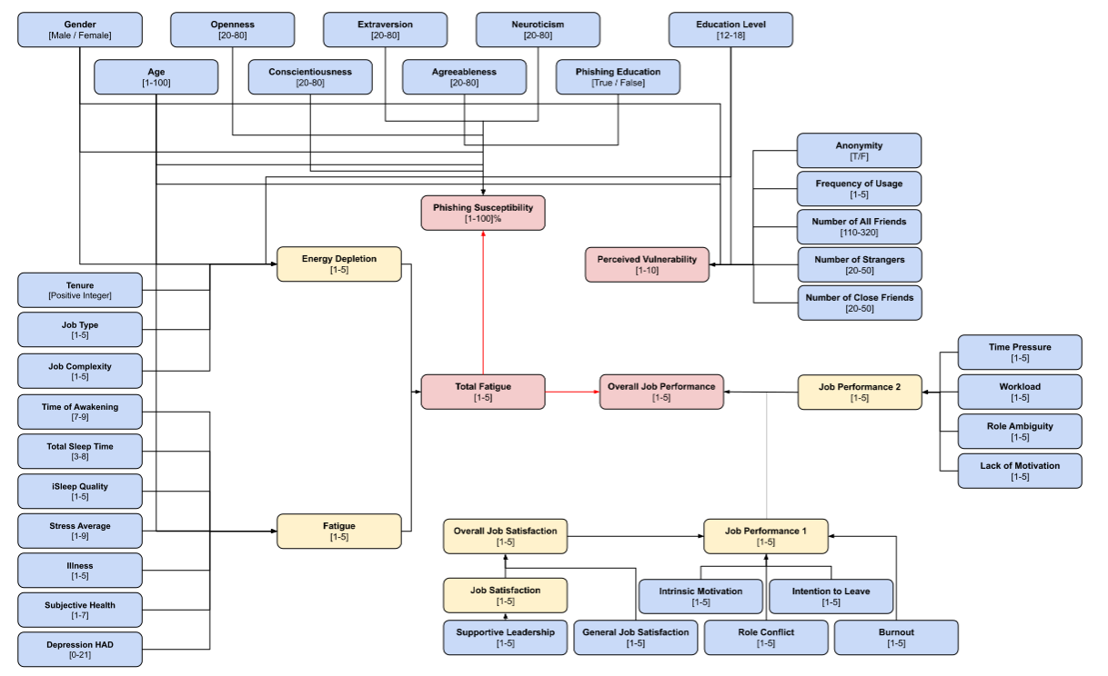
Representation of the complexity of the dynamic stats that govern the synthetic agents

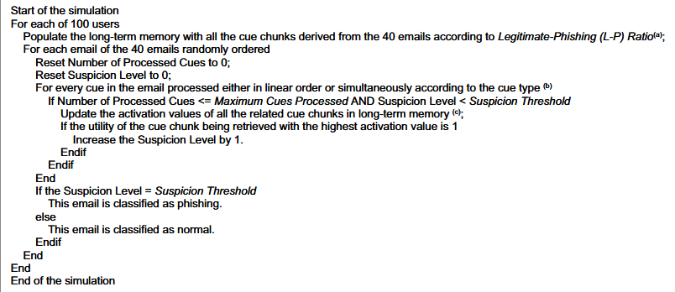
Model showing the agent’s ‘Cognitive Brain’ uses cues and memory to reach a decision based on a Suspicion Threshold

TABLE OF CONTENTS

Chapter No. | Title | Page No.
 | INTRODUCTION | 01
 | PROBLEM DEFINITION  2.1 Background and Motivation  2.2 Core Problem  2.3 Problem We Aim to Solve | 02
 | LITERATURE SURVEY  3.1 AI-Enhanced Social Engineering  3.2 Technical Evasion Techniques  3.3 Simulation-Based Approaches in Cybersecurity | 03
 | RESEARCH / TECHNOLOGY GAPS AND CHALLENGES | 04
 | DATA EXPLORATION(if any)  4.1 Overview  4.2 Dataset description | 05
 | CONCLUSION OF CAPSTONE PROJECT PHASE – 1 AND FUTURE WORK | 06
7.  8. | REFERENCES/BIBLIOGRAPHY  APPENDIX A DEFINITIONS, ACRONYMS, AND ABBREVIATIONS | 07  08

LIST OF TABLES

Table No. | Title | Page No.
Table 1 | Effectiveness of human-crafted and LLM-generated phishing email | 3
Table 2 | Client-side cloaking techniques used | 4
Table 3 | Correlation of Dynamic Factors with Organizational Damage | 6

LIST OF FIGURES

Figure No. | Title | Page No.
Figure 1 | Histogram of compromised visitor traffic | 4
Figure 2 | Simulation framework overview | 5
Figure 3 | Clustering of participants in the no-multitasking condition | 7
Figure 4 | Decision making process of agents in response to Emails | 8

CHAPTER 1

INTRODUCTION

The rising trend of large language models has greatly changed the way phishing attacks work. Many of the earlier attempts at phishing could be identified by grammatical errors, generic messages, or even suspicious-looking formats. Today, through AI, the bad actors can generate highly personalized and well-structured messages at scale, evading manual detection and automated filtering. These AI-generated messages can mimic internal communication tone, organizational tone, and contextual relevance to users, building user trust and reducing the traditional warning signs.

Besides the sophistication of the content itself, numerous evasion techniques-such as browser fingerprinting, interaction-dependent content delivery, and client-side cloaking-enable phishing pages to only present their malicious content to genuine users while evading automated scanners. This extends the time the attack can remain active and increases the chances of victims clicking on malicious links or providing sensitive information. Live phishing tests cannot be carried out in natural environments due to various legal, ethical, and privacy restrictions. The research project now tries to create a controlled simulation environment which models how phishing attacks spread and how different users react to them in an environment devoid of real-world consequences.

CHAPTER 2

PROBLEM DEFINITION

2.1 Background and Motivation

Phishing remains a very successful attack vector because of its dependence on human error. As generative AI became more advanced, phishing attacks became more sophisticated and adaptive, rendering traditional rule-based systems for phishing detection increasingly irrelevant. Attackers generate context-specific content in near real-time that allows for very targeted, scalable attacks. Lateral phishing attacks-where an attacker uses an already compromised account inside of an organization-massively amplify trust and lower suspicion for recipients.

2.2 Core Problem

Empirical studies of AI-driven phishing are risky, illegal, and infeasible. Deploying phishing sites, collecting user data, and observing human behavior under live-attack conditions violates ethical and privacy regulations. Most literature only abstracts the human response to a binary outcome, such as click/no-click, without granularity in behavioral proxies (e.g., hesitation, partial form fill) or times spent evaluating content. Furthermore, the interplay between technical evasion, like cloaking, and human factors remains an area that is less explored.

2.3 Problem We Aim to Solve

The project proposes a Hybrid Agent-Based Simulation framework that can mimic both human decision-making and technical evasion stages of phishing attacks. The project creates a controlled simulation of the organizational communication network for the systematic evaluation of attack dynamics, susceptibility patterns, and the effectiveness of evasion strategies without real-world risk. This addresses the absence of research environments that can safely analyze AI-enhanced phishing campaigns.

CHAPTER 3

LITERATURE REVIEW

3.1 AI-Enhanced Social Engineering

Recent studies have shown that LLMs have eliminated traditional phishing cues by generating high-quality and highly contextual content. Large-scale organizational studies with thousands of employees have also demonstrated that LLM-generated lateral phishing emails can achieve equal or superior open and click-through rates to those authored by human experts [1]. Also, hybrid models that infuse LLM generation with cognitive frameworks demonstrate near-human efficacy while drastically reducing the effort, cost, and expertise requirements of the attacker [3]. These findings confirm previously raised concerns over the scalability and precision of AI-powered social engineering.

Email Author | Email Topic | Email Recipients | Emails Opened (Rate) | Link Clicked (Rate) | Data Entered (Rate)
Human | Supervisor to Direct Report | 1541 | 955 (61.97%) | 334 (21.67%) | 164 (10.64%)
LLM | Supervisor to Direct Report | 1490 | 919 (61.68%) | 318 (21.34%) | 165 (11.07%)
Human | Timely Phishing | 1591 | 574 (36.08%) | 106 (6.66%) | 40 (2.51%)
LLM | Timely Phishing | 1479 | 597 (40.37%) | 153 (10.34%) | 62 (4.19%)
Human | Common Phishing | 1520 | 831 (54.67%) | 68 (4.47%) | 18 (1.18%)
LLM | Common Phishing | 1508 | 715 (47.41%) | 73 (4.84%) | 14 (0.93%)
Total Human Written | — | 4652 | 2360 (50.73%) | 508 (10.92%) | 222 (4.77%)
Total LLM Generated | — | 4477 | 2231 (49.83%) | 544 (12.15%) | 241 (5.38%)
Total | — | 9129 | 4591 (50.29%) | 1052 (11.52%) | 463 (5.07%)
Table 1: Effectiveness of human-crafted and LLM-generated phishing email

3.2 Technical Evasion Techniques

Similarly, works like CrawlPhish show that more than 30% of phishing sites use client-side cloaking mechanisms in order for their detection systems to fail [11]. Such techniques include user-interaction checks, browser fingerprinting, and filtering on bot behaviour-all of which make the automated scanners far less effective. The "Golden Hour" concept illustrates how phishing campaigns take advantage of a critical time window where detection systems do not react yet. Models such as KnowPhish extend defences through multimodal knowledge graphs and LLM-derived textual intent, addressing gaps in logo-based or static detectors [5]. These insights provide the foundation to model technical evasion in the proposed simulation.

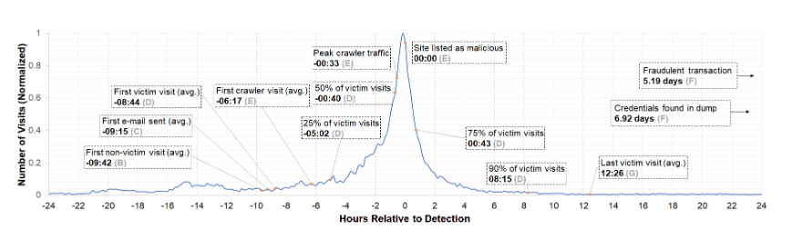
Figure 1: Histogram of compromised visitor traffic

Cloaking Category | Cloaking Type | Requirement
User Interaction | Pop-up  Mouse Detection  Click Through | Click on alert/notification window  Move mouse over browser  Pass Click Through on browser
Fingerprinting | Cookie  Referrer  User-Agent | Check document.cookie  Check document.referrer  Check navigator.userAgent
Bot Behaviour | Timing  Randomization | Render webpage after a certain time  Show content randomly using Math.random()
Table 2: Client-side cloaking techniques used

3.3 Simulation-Based Approaches in Cybersecurity

Agent-based modelling has successfully modelled human behaviour, cognitive biases, and susceptibility factors in phishing research. Various research shows that factors like fatigue, perceived vulnerability, job pressure, and level of attention significantly impact decision-making [9]. The cognitive models provide further explanations about how users assess cues while dynamically adjusting their suspicion threshold based on context and memory [10]. However, existing simulations mainly depend on static parameters, lack specific behavioural details, and hardly include technical evasion techniques. This paper will thus unify the elements mentioned above to develop an integrated simulation model.

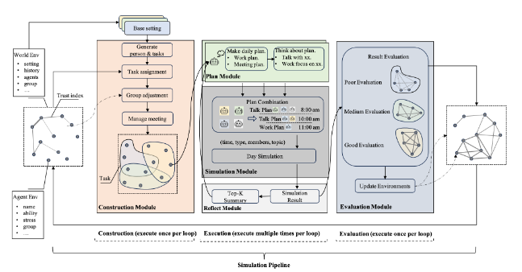
Figure 2: Simulation framework overview

CHAPTER 4

RESEARCH/TECHNOLOGIES GAPS AND CHALLENGES

One such research gap is in the restricted understanding of how technical evasion strategies interact with human decision-making. The current state of the art either analyses phishing websites or user psychology separately; few works investigate their interaction. This interaction is important because, while evasion techniques are responsible for prolonging exposure, psychological factors dictate how users react within a varying context of trust, fatigue, or urgency. It is otherwise hardly possible to estimate realistic attack success rates or test defence mechanisms without an integrated framework.

Defensive challenges also stem from the limitations of modern detection systems. LLM-generated content is extremely adaptable, and minor changes based on prompts can easily pass filters. Detection of unknown LLM-generated emails presents a particular challenge because such models can generate content in divergent styles. On the technical side, the real-time analysis of cloaking or behavior-based scripts requires expensive computation and may still fail against sophisticated client-side evasion. Behavioral issues further complicate matters: users are influenced by cognitive biases, contextual triggers, and organizational hierarchies-all those things that an attacker can leverage. These dynamic factors are not considered by current training programs, so their awareness strategies have to be generalized and often fail. Addressing these gaps requires a simulation model capable of integrating technical evasion with cognitive and behavioural variability.

Predictor | B | SD B | β | t | p
(Constant) | 65.556 | 1.003 |  | 65.389 | <0.0001
Average Job Performance | -2.292 | 0.214 | -0.002 | -10.693 | < 0.0001
Average Fatigue | 0.608 | 0.158 | 0.001 | 3.841 | 0.0001
Average Perceived Vulnerability | -5.584 | 0.057 | -0.020 | -98.608 | < 0.0001
Table 3: Correlation of Dynamic Factors with Organizational Damage
CHAPTER 5

DATA EXPLORATION

5.1 Overview

Data exploration in this stage focuses on the understanding and preparation of two major components: a) the human behavioral model, and b) the cognitive classification model that agents use in assessing phishing emails. The simulated environment is a virtual organization with 235 agents with varied attributes like fatigue, perceived vulnerability, and job performance. These are based on empirical regression models from previous research.

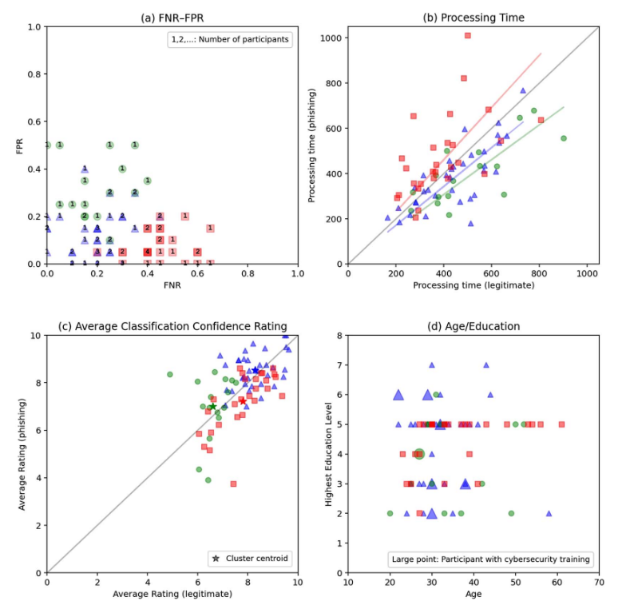
Figure 3: Clustering of participants in the no-multitasking condition

5.2 Dataset Description

The cognitive component uses a curated dataset of 40 email samples, including 20 legitimate and 20 phishing emails. These samples populate the agent's long-term memory and form the basis of decision-making during simulations. Parameters such as suspicion thresholds and flawed perception levels influence how agents classify emails. The L–P ratio is deliberately skewed using duplication of legitimate email samples to reflect realistic exposure patterns where legitimate emails outnumber phishing attempts. This dataset allows the simulation to model hesitation, misclassification, and gradual susceptibility changes over time. Even though this dataset is relatively small, its purpose is to demonstrate Phase–1 feasibility and provide the foundation for a much larger, more dynamic dataset in Phase–2. The team developed a broad literature survey and identified key gaps in existing phishing detection research and developed a structured workflow for simulating attack scenarios. This has clearly brought out the need for safe, ethical, and scalable simulation environments to study AI-driven phishing attacks that cannot be experimentally deployed in real-world settings. Future work will focus on the implementation of the complete simulation architecture, further enhancement of cognitive models, integration of multimodal phishing scenarios-voice and visual attacks, and expansion of the behavioral dataset. Phase–2 will further introduce real-time analytics dashboards, threat progression based on scenarios, and reinforcement learning components to evaluate adaptive defenses. The resultant outcome will ensure more accurate and actionable insights into organizational susceptibility while helping develop targeted defensive strategies.

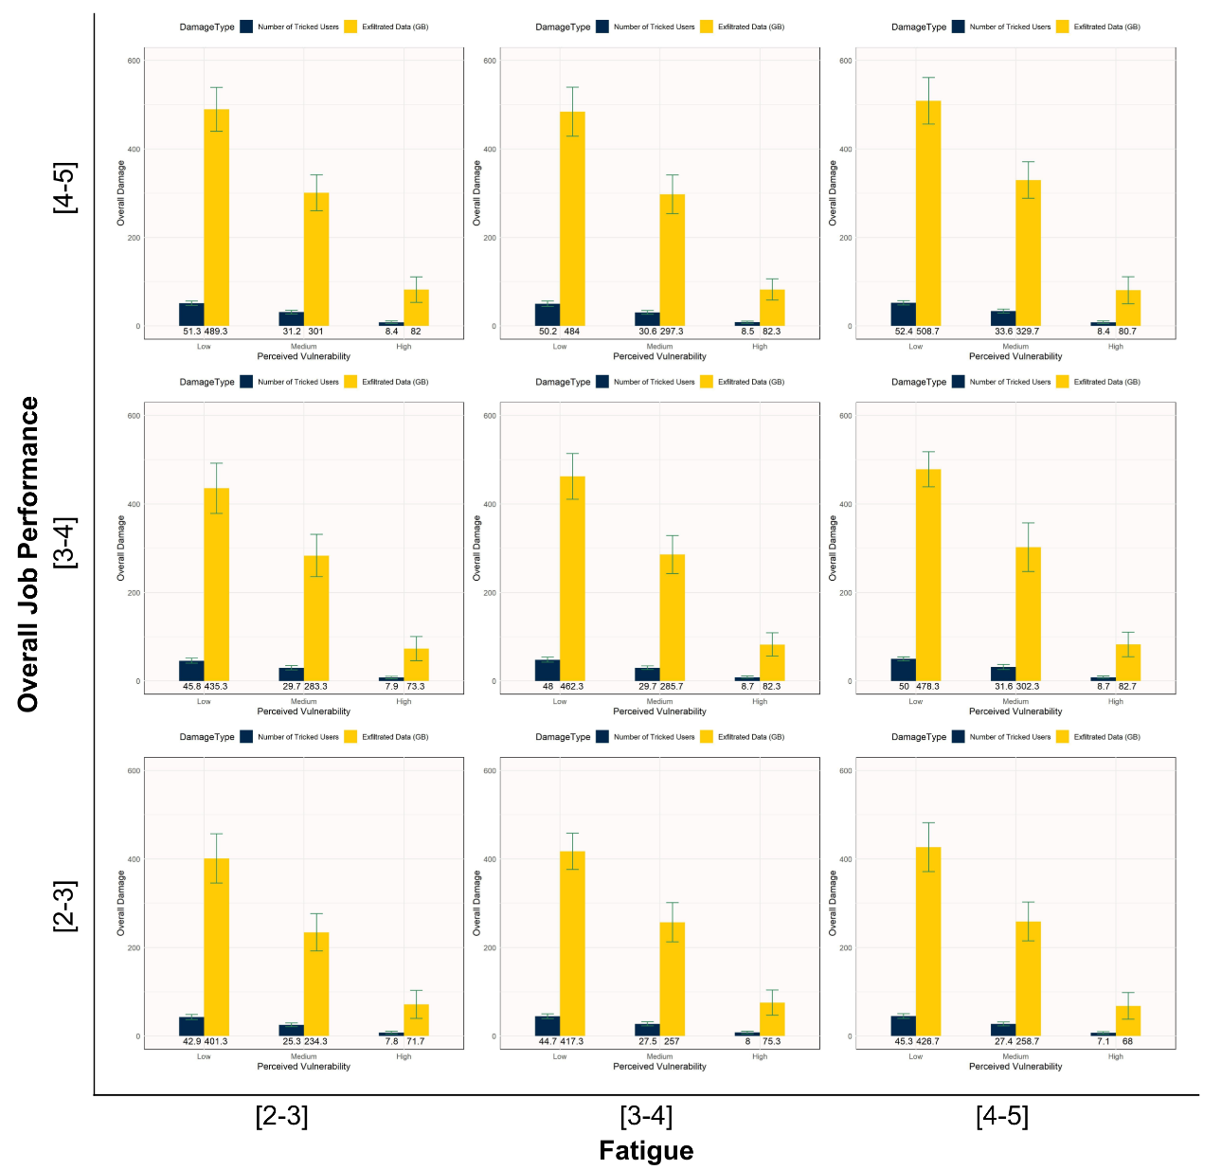
Figure 4: Decision making process of agents in response to Emails
CHAPTER 6

CONCLUSION OF PHASE-1 AND FUTURE WORK

The conceptual grounds for a framework of AI phishing simulation using hybrid agent-based modeling were successfully laid in Phase-1. A wide literature survey was conducted by the team where critical gaps were identified in the current research related to phishing detection. A structured workflow was developed for simulating attack scenarios. The project clearly demonstrates the need for safe, ethical, and scalable simulation environments to study AI-driven phishing attacks that cannot be experimentally deployed in real-world settings.

Future work will concentrate on the complete simulation architecture, further refinement of the cognitive models, inclusion of multimodal phishing scenarios-both voice and visual attacks-and the building of an extended behavioral dataset. Furthermore, Phase–2 will add real-time analytics dashboards, scenario-based threat progression, and reinforcement learning components for the evaluation of adaptive defenses. This will provide more accurate and actionable insights about the organizational susceptibility and will help build out targeted defensive strategies.

REFERENCES
[1] M. Bethany et al., “Large language model lateral spear phishing: A comparative study in large-scale organizational settings,” arXiv:2401.09727, 2024.
[2] G. Eason et al., “On certain integrals of Lipschitz-Hankel type,” Phil. Trans. Roy. Soc. A, 1955.
[3] F. Heiding et al., “Devising and detecting phishing emails using large language models,” IEEE Access, 2024.
[4] G. Ho et al., “Detecting and characterizing lateral phishing at scale,” USENIX Security, 2019.
[5] Y. Li et al., “KnowPhish: LLMs meet multimodal knowledge graphs,” arXiv:2403.02253, 2024.
[6] A. Oest et al., “Sunrise to sunset: Analyzing the end-to-end life cycle of phishing attacks,” USENIX Security, 2020.
[7] S. S. Roy et al., “From chatbots to phishbots,” IEEE S&P, 2024.
[8] M. Sharma et al., “How well does GPT phish people?” EuroS&PW, 2023.
[9] J. Shin et al., “Integrating human factors into agent-based phishing simulation,” SBP-BRiMS, 2023.
[10] M. Shonman et al., “Using a computational cognitive model to understand phishing decisions,” Interacting with Computers, 2024.
[11] P. Zhang et al., “CrawlPhish: Analysis of client-side cloaking techniques,” IEEE S&P, 2021.

APPENDIX A — DEFINITIONS, ACRONYMS, AND ABBREVIATIONS
- LLM – Large Language Model
- ABM – Agent-Based Modeling
- L–P Ratio – Legitimate–Phishing Email Ratio
- Cloaking – Technique used to hide malicious behavior from scanners
- Golden Hour – Time window before phishing detection systems react
- PII – Personally Identifiable Information
- AI – Artificial Intelligence

